Author: Alyssa Pereslete

Last Updated: 7/18/19

Estimated time: 30 minutes total

Adapted from Davies Lab Chlorophyll Extraction Protocol

**Materials**:

* Gloves
* Culture samples
* 90% Acetone (fridge)
* Deionized water
* Micro-pipette (1 mL max)
* Micro-pipette (20-200µg)
* Refrigerated Centrifuge
* Bead-mill
* Refrigerator
* Photo Spectrometer
* Fume Hood

1. Dim lab lights as much as possible.
2. After counts are completed, use scoopula and small weigh boat to place small amount of glass beads in each bead blast tube (see picture, should barely cover the bottom)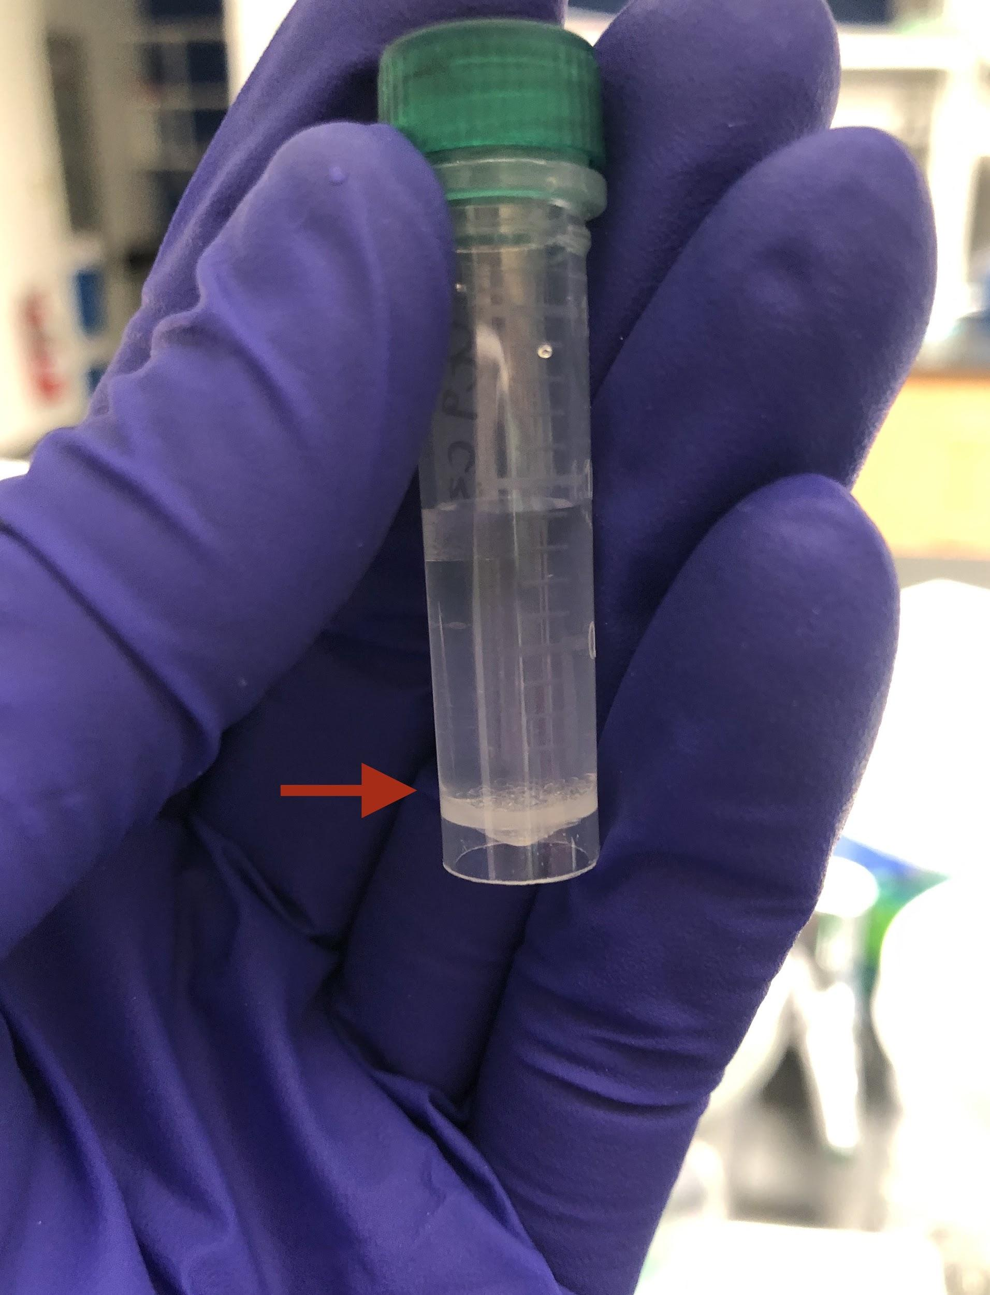
3. Open the centrifuge and place the samples inside, ensuring to balance to centrifuge and full click on the cover.
4. Centrifuge for 2 min at max RPM (14.8) and 4℃ to separate the media supernatant from the symbiont cell parts.
5. After the centrifuge finishes running and while ensuring not to disrupt the contents of the samples, check to see if the supernatant is clear and lacking a green shade. This will indicate the pelleting was successful.
6. Using the 1mL maximum micro-pipette, carefully remove supernatant without disturbing pellet. Remove any remaining supernatant with the 20-200µg micropipette.
7. Add 1mL of 90% acetone to each tube once the supernatant has been drained.
8. Run the samples in the bead mill at 6.00 m/s for 2 minutes.
9. Cover each sample with foil (should be in the incubation box) and incubate in darkness for 24 hours in the fridge.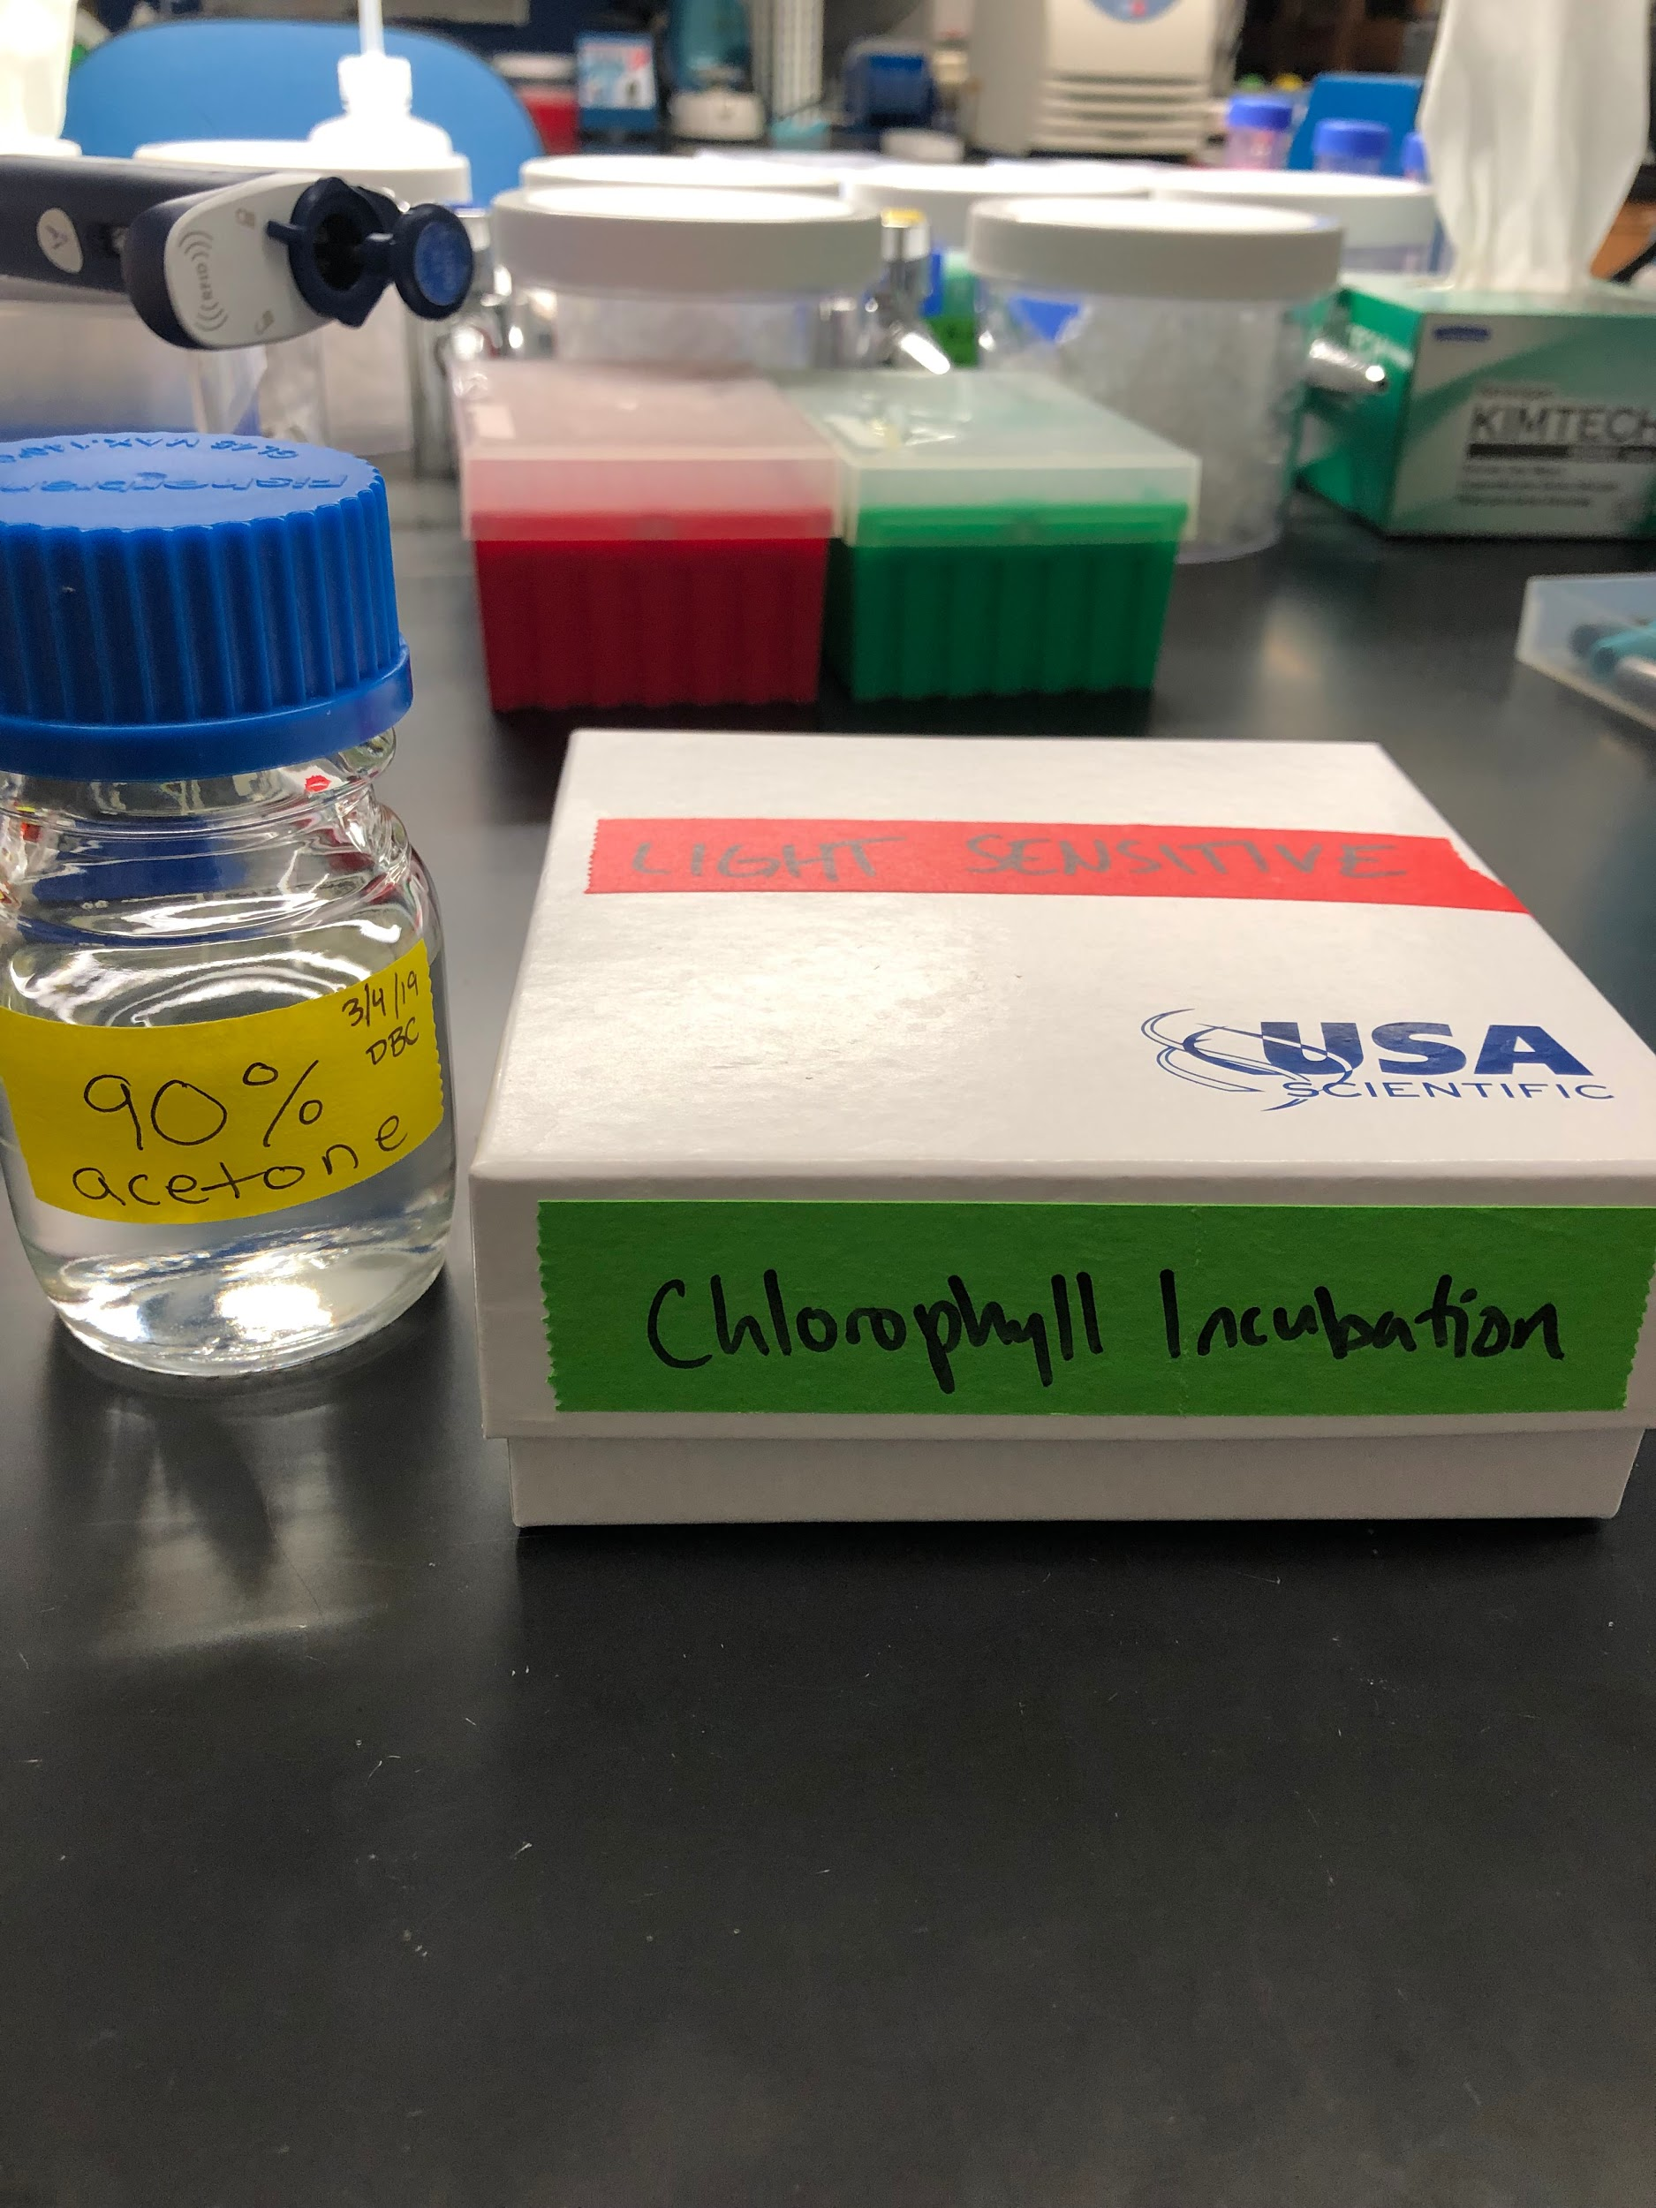
10. Keep the samples on ice and in foil once removed from fridge after 24 hour incubation
11. Centrifuge the samples again for 1 minute at max RPM (14.8), 4℃.
12. Plate samples in triplicate (200µg) and read absorbance at 630nm and 663 nm, use 90% acetone as blank. See picture for plate layout. Clear lidded assay plates or black assay

plates with clear bottoms can be used, but plate type must be consistent within a project. Plates can be rinsed and reused between readings.

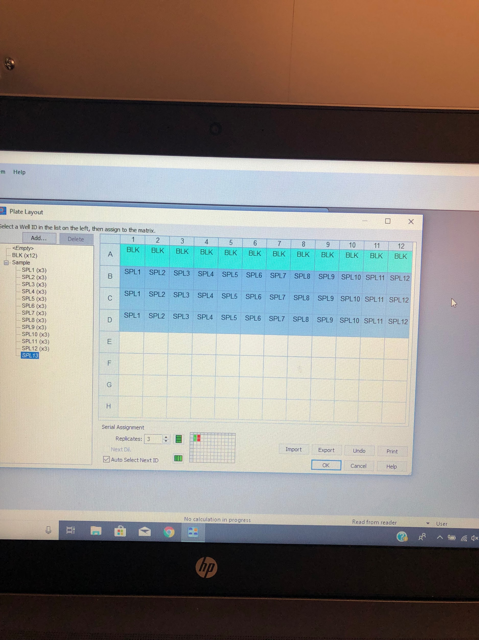

1. Protocol on Gen5 is called “Chlorophyll Assay”. If plate layout is different from photo above, edit plate layout before running.
2. Export data to excel (folder on desktop labeled Alyssa->Chlorophyll) and email.
3. Dispose of sample tubes in fume hood- container labeled “Chlorophyll Assay”
4. Rinse plate with DI water into waste container and dispose of in container labeled “Chlorophyll Assay”